Standard Operating Procedure
Calorimetry using Parr Semi-micro Oxygen Bomb

Purpose
The purpose of this standard operating procedure is to ensure that correct and consistent methods are used while determining energy density using the Parr Semi-micro oxygen bomb calorimeter.

Equipment and Supplies

Data sheet
Parr calorimeter
Parr combustion vessel with bucket
Volumetric flasks (200 and 250 mL)
~ 20 L of room temperature tap water
Sample press with dies
Set-up stand
Balance
Small weighing boat
Benzoic acid calorimetery standard
99.5% purity oxygen
Fuse wire
Plastic ruler
Forceps
Scissors

Procedure
- Start calorimeter and let it warm up for 20 minutes.
- Use a benzoic acid standard for the initial combustion of the day to test the equipment and ensure things are operating correctly. A standard should be burned every tenth operation of the calorimeter to measure variance.
- Fill the glass bucket with exactly 450 g of room temperature tap water. Precision is important as the calorimeter is calibrated for this amount of water, as too much or too little water will cause erroneous data. The water will need to be changed after each sample run.
- Place the combustion chamber holder into the glass bucket with the electrical lead attached. The lead should never be detached from the holder. Align the hook of the holder closest to the electrical lead at about the 3 o’clock position in the bucket. This is to allow the electrical leads to exit the bucket through a small slot in the top cover.
- Place the bomb head assembly upside down in the set-up stand. This makes step 6 easier.
- Measure 100 mm of fuse wire using the plastic ruler, cut with scissors, and attach it to the electrodes of the combustion chamber as shown in Figure 1. Coil the bottom of the fuse wire winding it to the top of the crucible. It is easier to just wind the fuse wire around the forceps as opposed to the methods shown in the figure.
- Tare the small weighing boat on the balance each time before weighing the sample.
- The sample should weigh 0.03 – 0.2 g, and tends to work best if the sample weighs 0.04 – 0.065 g.
- Pull down on the press handle to pelletize the sample. Be somewhat gentle with the press as too much force can cause lipids to be squeezed out, but too little force can cause the sample to fall apart in the next steps. Use a sample with enough back-up material when first learning so it can be redone if needed.

- Place either a benzoic acid standard or pelletized sample into the small weighing boat and record the weight to the nearest 0.0001 g.
- Flip the bomb head assembly in the set-up stand.
- Transfer the sample to the crucible while lifting the fuse wire out of the way. Be extremely careful not to crush the pelletized sample with forceps. It is easy to do.
- Lift the wire back onto the sample and let it come into contact without touching the crucible or any parts of the head assembly other than the electrode leads.
- Ensure the O-ring is in the top of the cylinder, then very carefully insert the head assembly and screw on the cap. The cap only needs to be snug, otherwise it will be difficult to take apart at the end of the run.
- Pressurize the bomb with oxygen by placing the fitting over the valve assembly (Figure 2), then VERY slightly open the valve on the tank. Make sure the valve assembly on the bomb is open. It only needs to be cracked open. Continue filling until the gauge reads 30-32 atmospheres of pressure. This occurs very quickly. Close the valve using the pin wrench. Again, only finger tight.
- Release the excess oxygen by slowly pulling the black lever on the tank valve.
- Remove the fill fitting.
- Insert the electrical lead into the terminal on the bomb head assembly.
- Place the bomb assembly into the bucket. Try not to disturb the pellet inside and do not lose any water from the bucket.
- Place the cover over the bucket while holding the two electrical leads together and align them with the slot on the cover.
- Replace the drive belt going from the stirring motor to the pulley on the cover.
- Press start on the control screen. The stirring motor will start. The calorimeter will ask for a sample number (the default number is fine) and then the weight of the sample. Enter the sample weight then press enter.
- The calorimeter will beep several times during operation, once when firing and again when done.
- Press “report” and select the top row (the sample that was just burned, it will be automatically highlighted).
  - Record the temperature rise and energy density from the sample on the data sheet.
  - Press “final” and you will be asked for the fuse correction. This is the amount of fuse wire that actually burned during combustion measured previously. The internal computer will then calculate a corrected energy density value.
- Remove the drive belt and bucket cover, then the bomb assembly and wire holder. Detach the electrical lead from the bomb assembly only.
- Empty the bucket into the sink and wipe dry with a paper towel. Refill and replace the bucket if another sample is going to be run.
- Using the pin wrench, loosen the valve on the top of the bomb head assembly to release all the pressure.
- Dry the bomb assembly with a paper towel and disassemble in the reverse order.
- Remove, straighten, and measure any unburned wire fuse to the nearest millimeter. Record the value on the data sheet. Subtract the value from 100 mm and record also.
- When done analyzing samples for the day leave the bomb disassembled with the head in the set-up stand. This allows everything to dry thoroughly.
- Replace the bucket and cover, then set the wire holder and electrical leads on top.
- Replace the dust covers on both the tank and calorimeter.
- Refill the carboy with water and allow to sit overnight to equalize to room temperature.

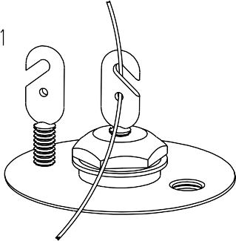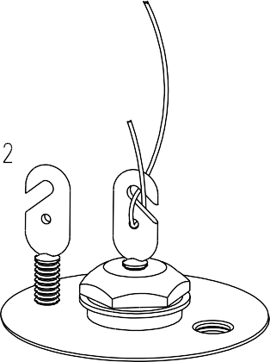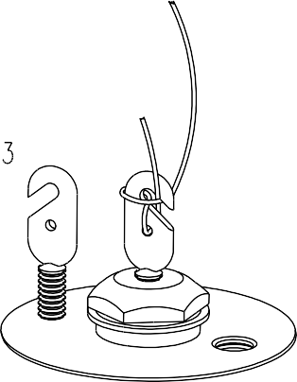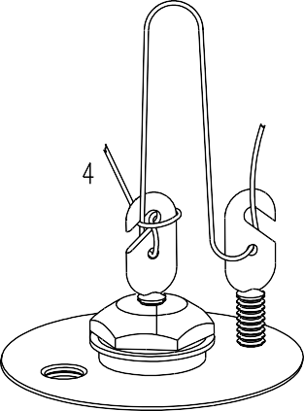

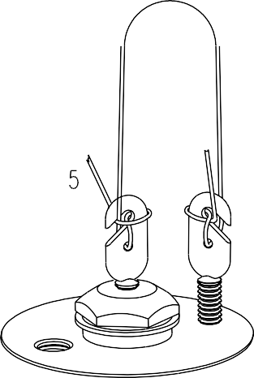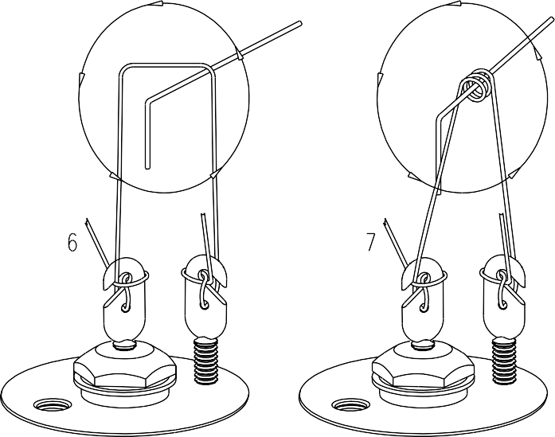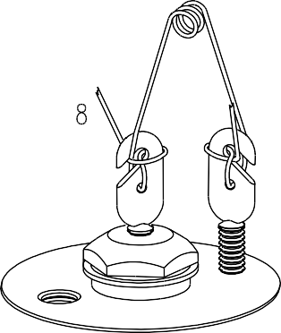
Figure 1. Technique for installation of fuse wire onto electrodes of combustion vessel. It is easiest to use small forceps to wind the fuse wire into a coil. Stop winding when the coil is even with the top of the crucible to allow for placement onto the pelletized sample. Figure is from Parr manual 492M, semi-micro oxygen bombs operating instruction manual.

B
A
Figure 2. Assembled Parr 1109A semi-micro oxygen bomb showing electrical terminal connection (A) and oxygen pressurization valve (B). Photo from Parr manual 492M, semi-micro oxygen bombs operating instruction manual.

